LAB ASSIGNMENT-7



NAME: M Gyanada Chowdary

REG.NO: 21bce7727

COURSE: Computer Networks

SLOT: L21+22

TASK:

configure a network and implement OSPF and RIP protocols in that network

and check for simulation after and before protocol implementation.

**OSPF (Open Shortest path First):**

Step 1:

Take 2 PCs, 2 Switches and 3 Routers and arrange them as Shown below:

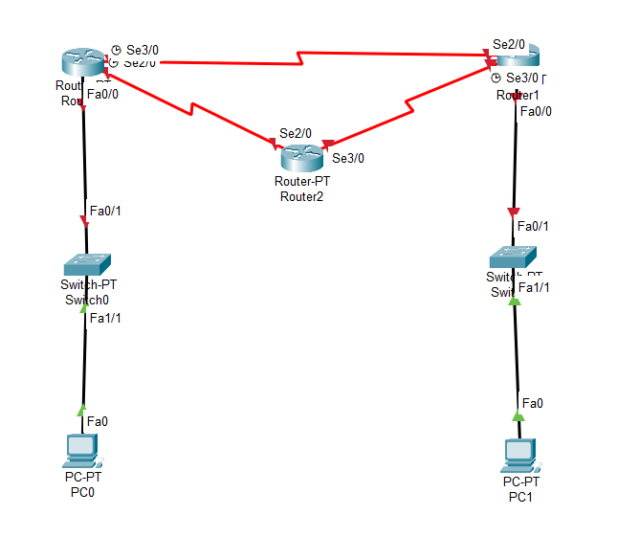

Step 2:

Give IP Adresses for the PCs

Network A – 192.168.1.0

Network B _ 165.155.1.0

PC0

IPV4 = 192.168.1.11

Default Gateway = 192.168.1.1

PC1

IPV4 = 155.165.1.11

Default Gateway = 155.165.1.1

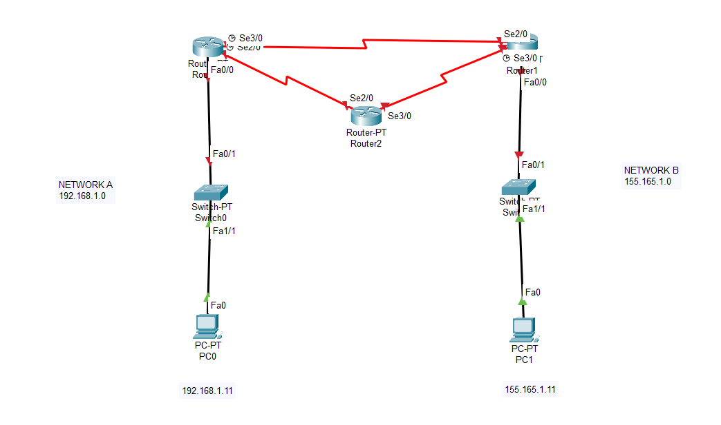

Step 2:

Configure the routers corresponding to the switches

Router0

Fa0/0 🡪

IPV4 = 192.168.1.1

Port status on

For Router1

Fa0/0🡪

IPV4 = 155.165.1.1

Port status on

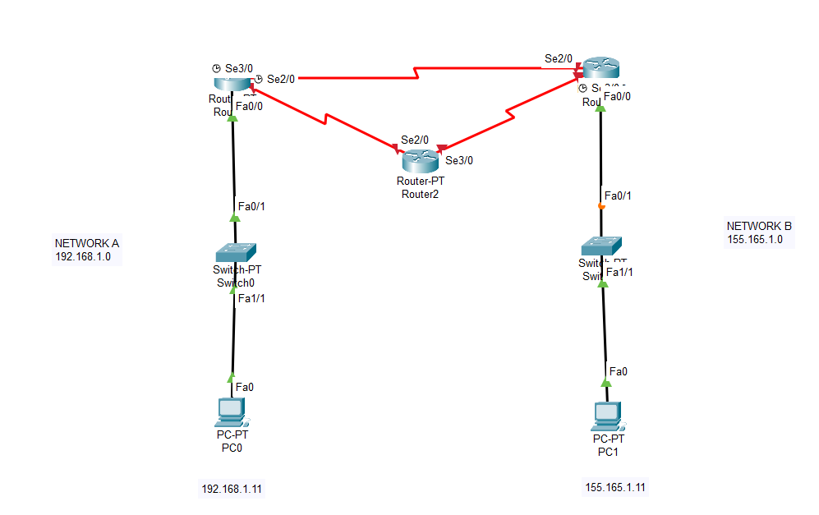

Step 3:

Configure the routers of the network.

With a clock

Clock rate – 64000

Without a clock

Clock rate _ not set

For every router with their particular interfaces

Configure them and switch the port status on.

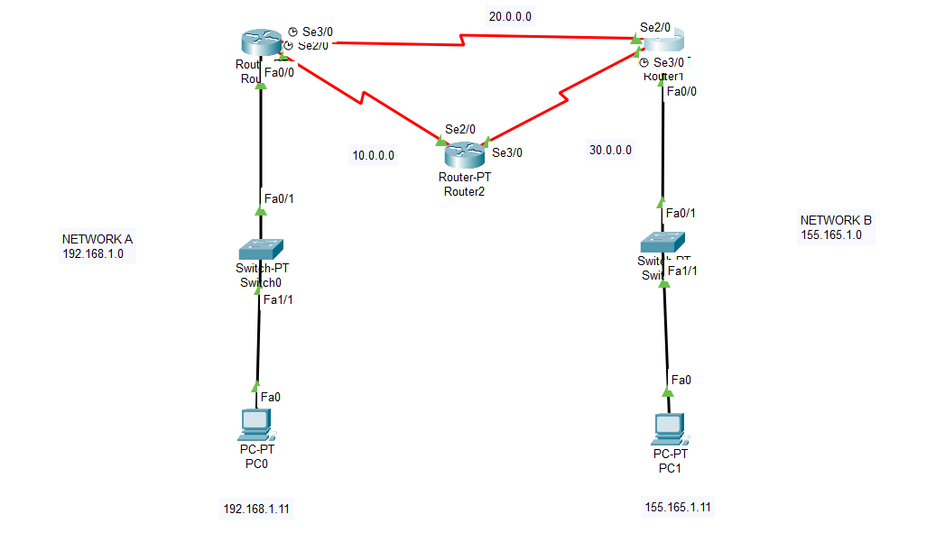

Step 4:

Implementing OSPF

For Router 0:

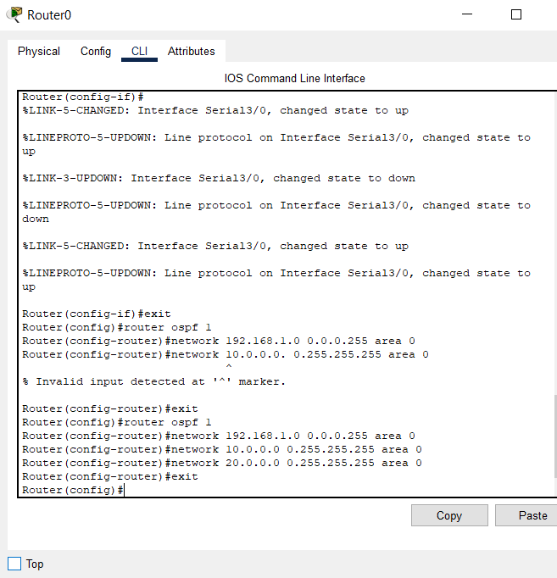

For Router 2:

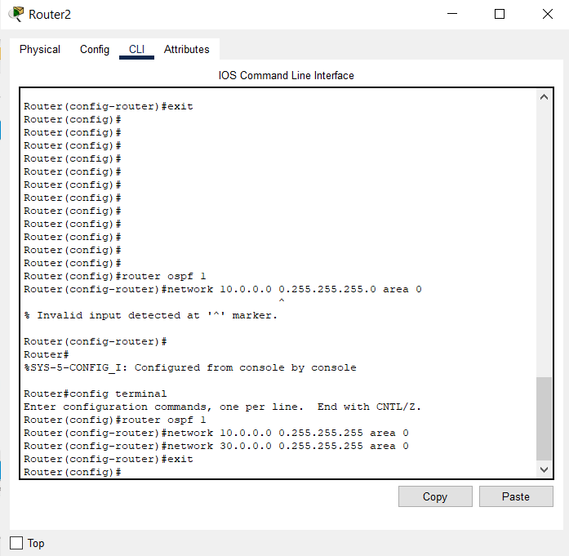

For Router 1:

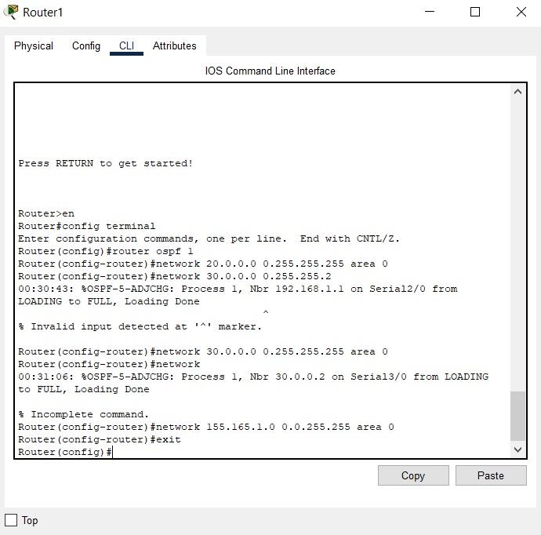

Step 5:

Take a simple PDU and check if the OSPF protocol is working

Steps

1)

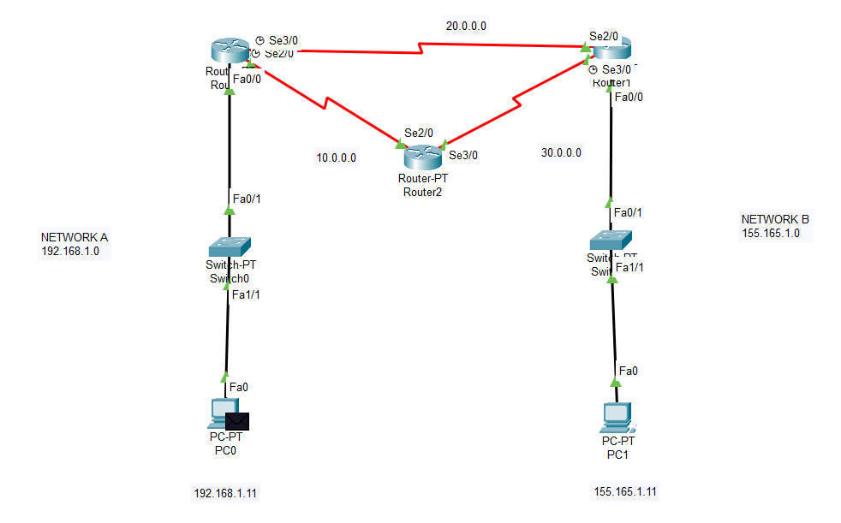

2)

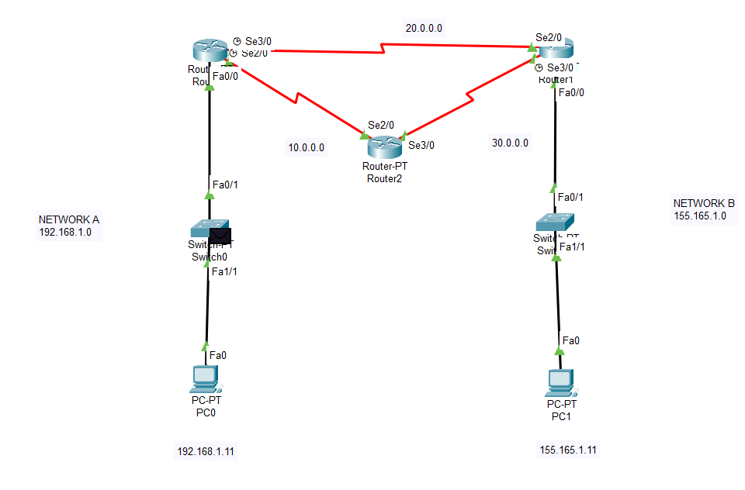

3)

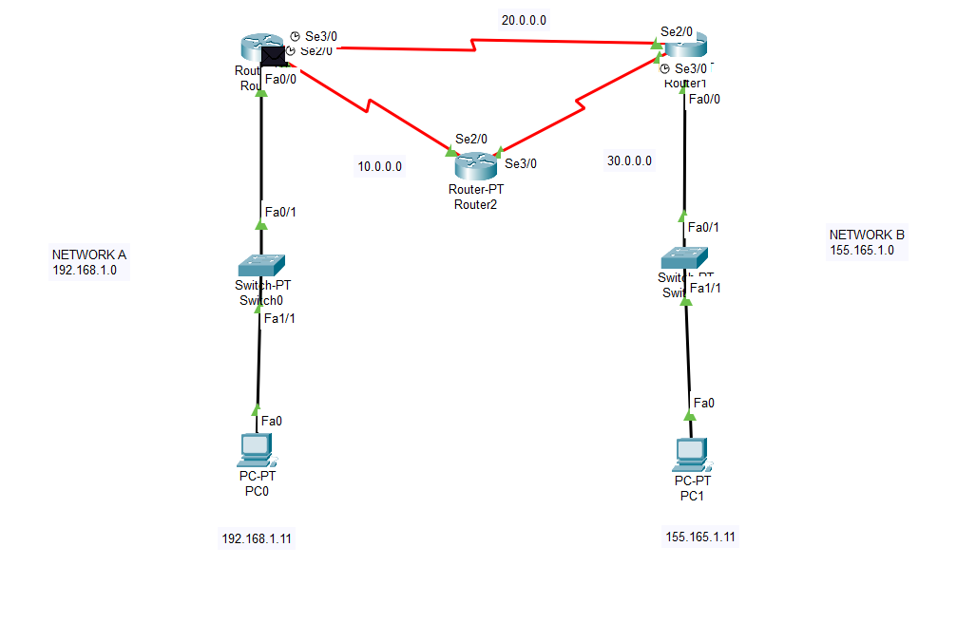

4)

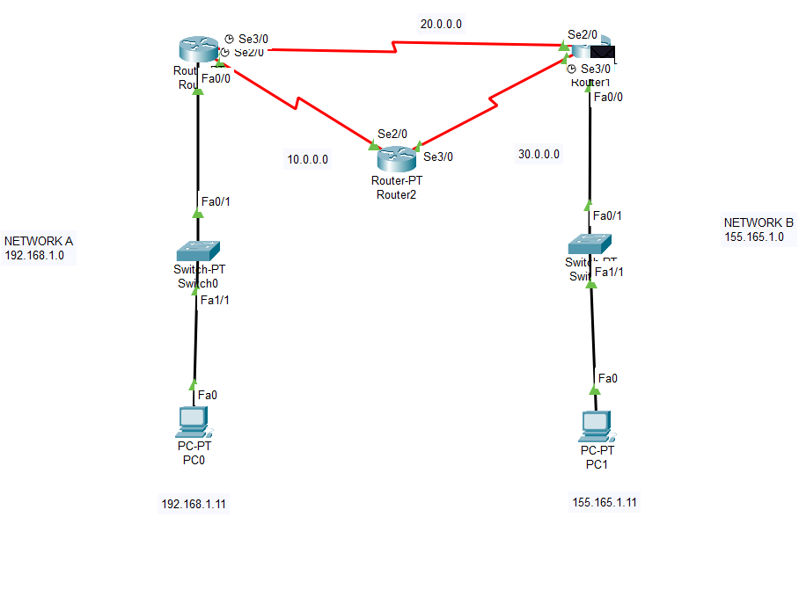

5)

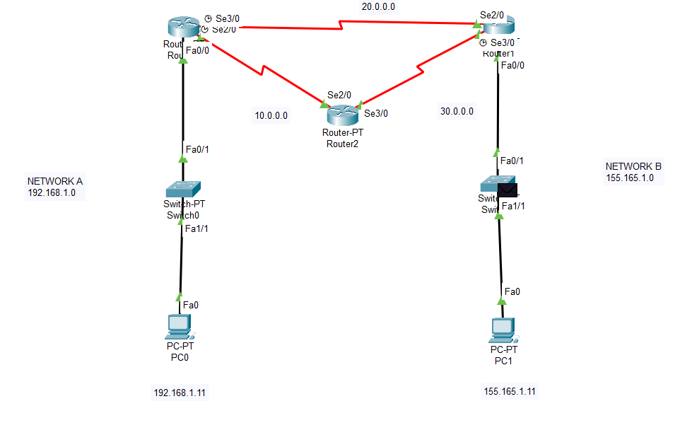

6)

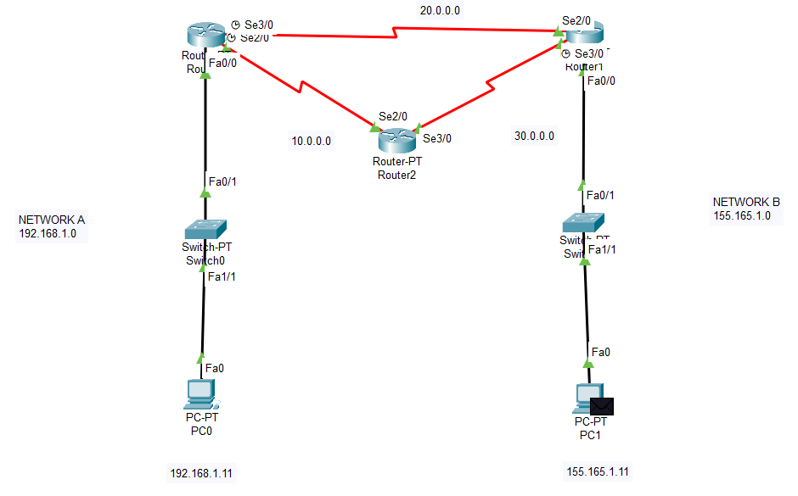

7)

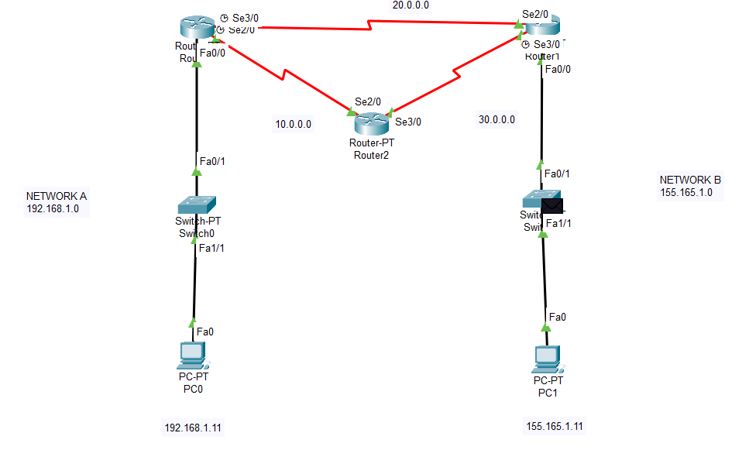

8)

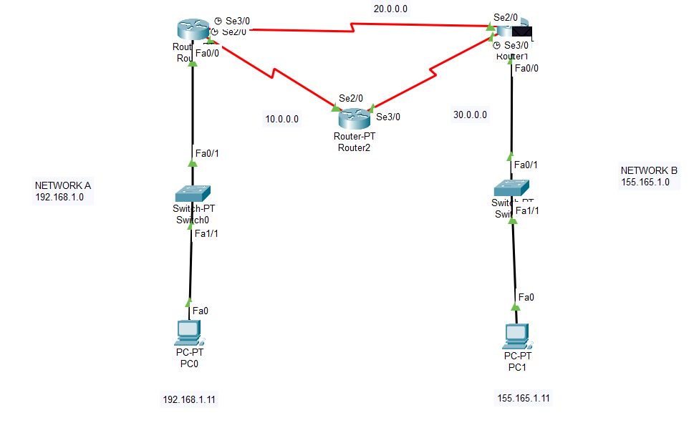

9)

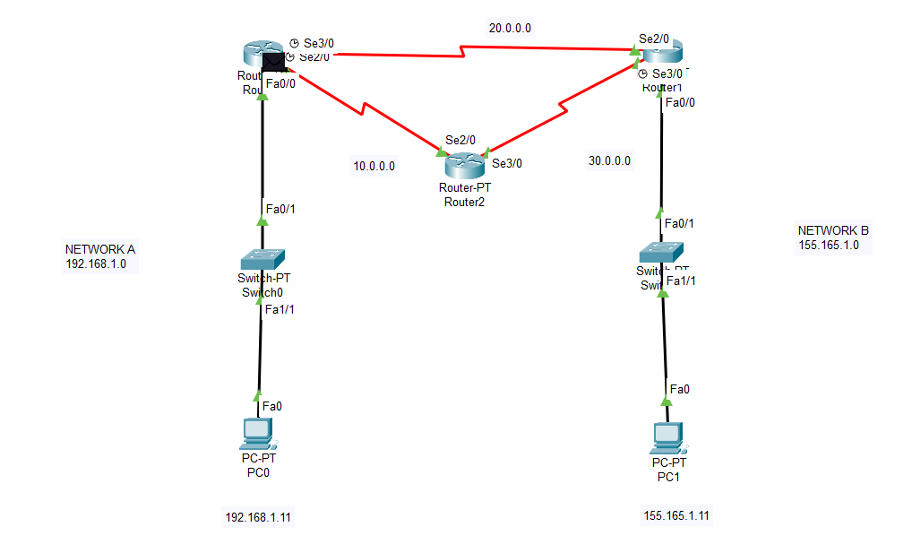

10)

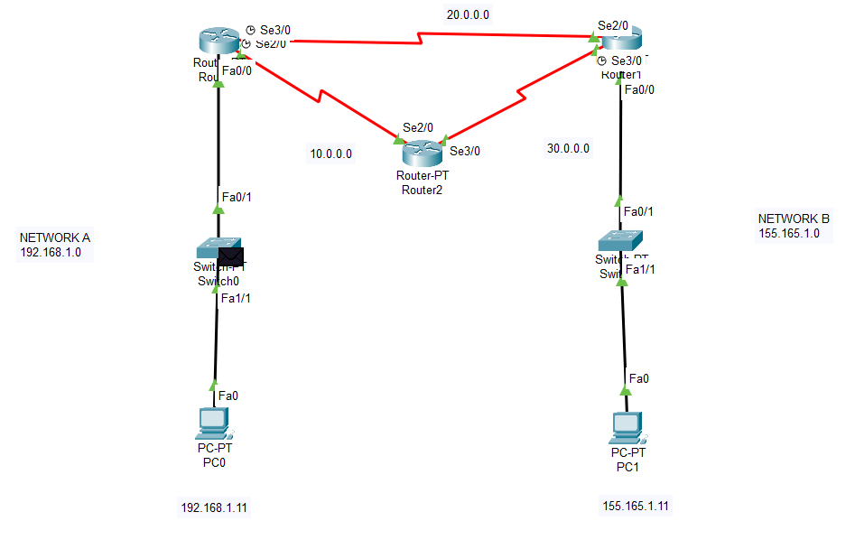

Final Output:

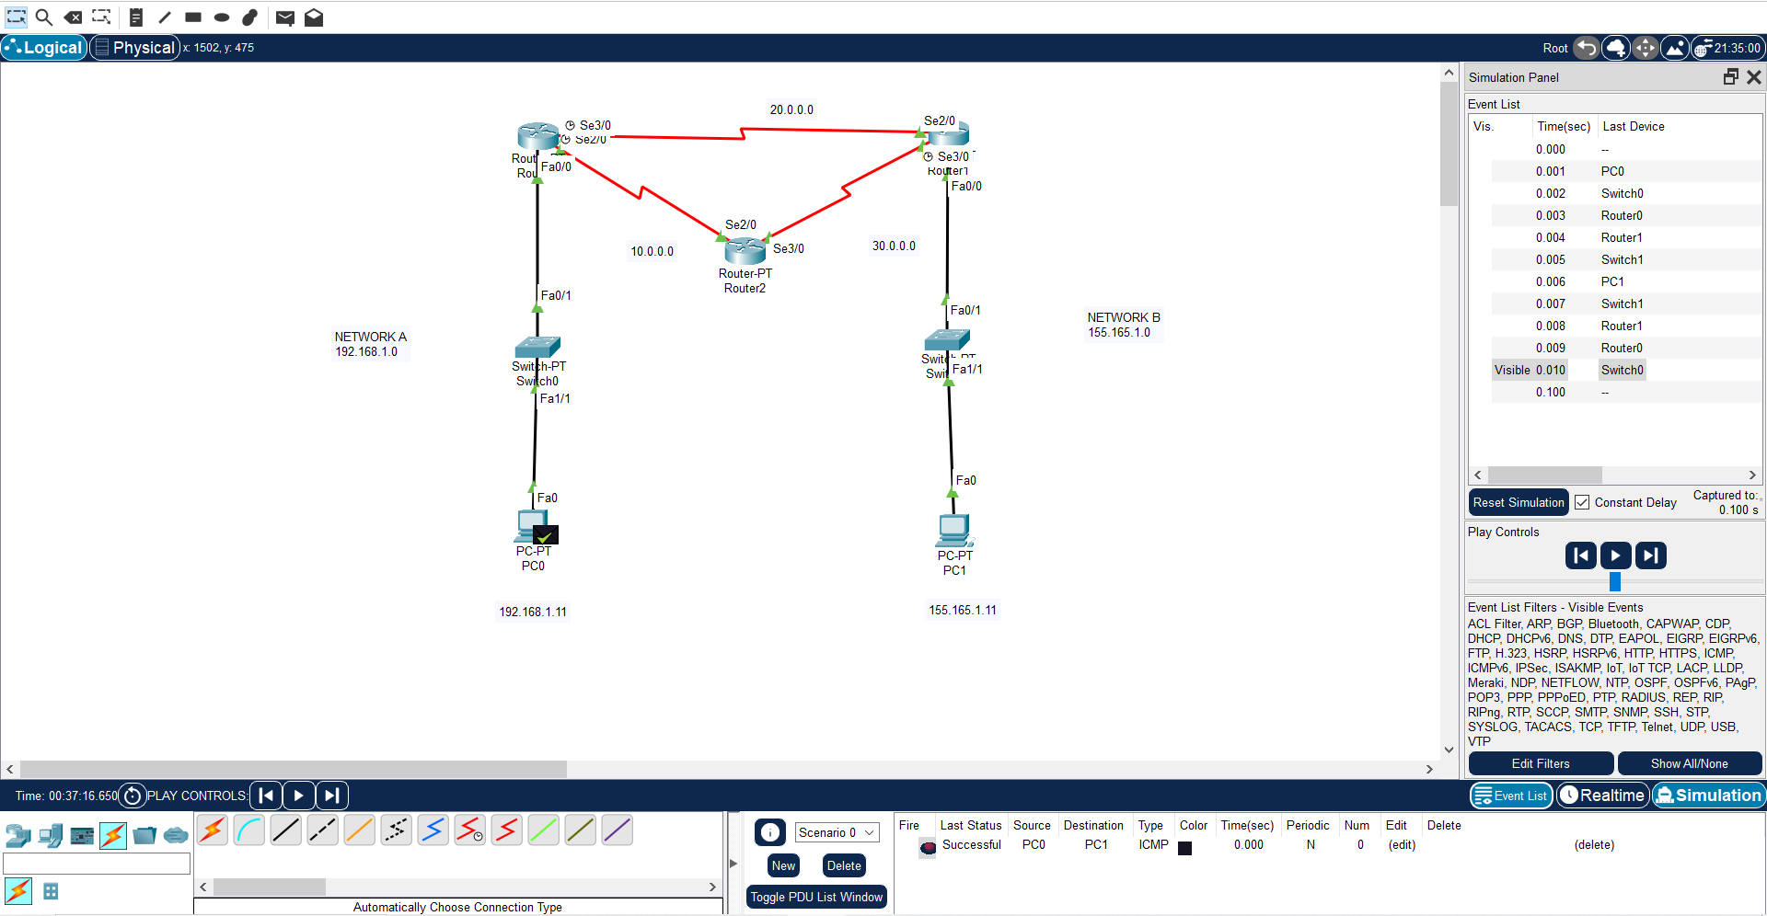

**RIP (Routing Information Protocol):**

Step 1:

Create a network shown as below

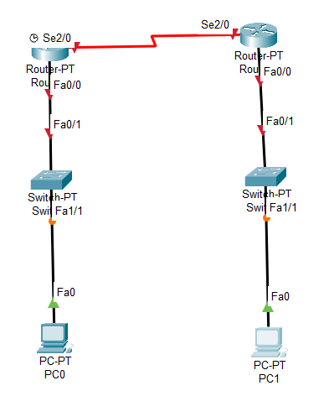

Step 2:

Give IP addresses to the PCs

For PC 0

IPV4 = 122.163.1.2

Default gateway = 122.163.1.1

For PC 1

IPV4 = 192.155.1.2

Default gateway = 192.155.1.1

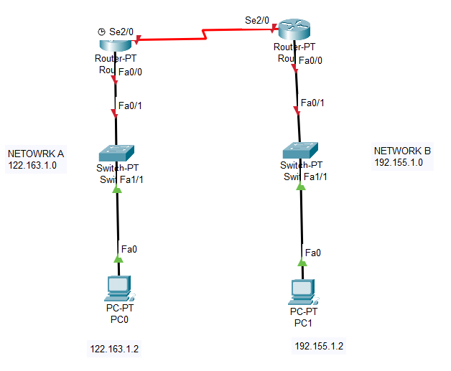

Step 3:

Configure the routers

For Router 0:

IPV4 = 122.163.1.1

Port status on

For Router 1:

IPV4 = 192.155.1.1

Port status on

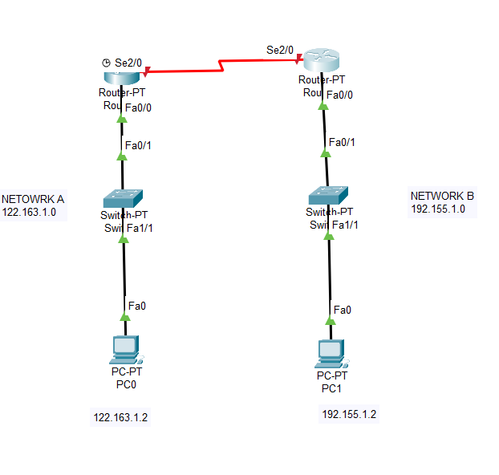

Step 4: Configure routers for network

For Router 0:

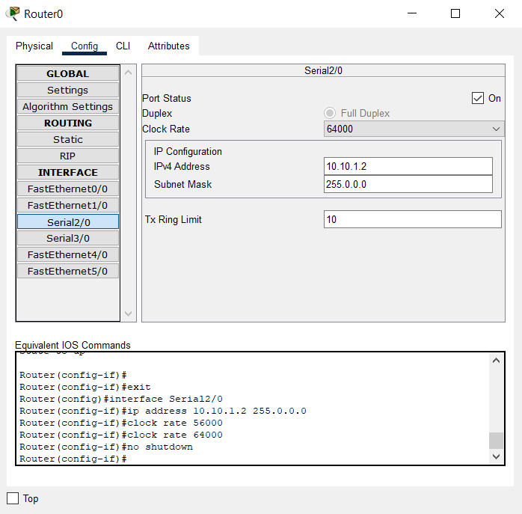

For Router 1:

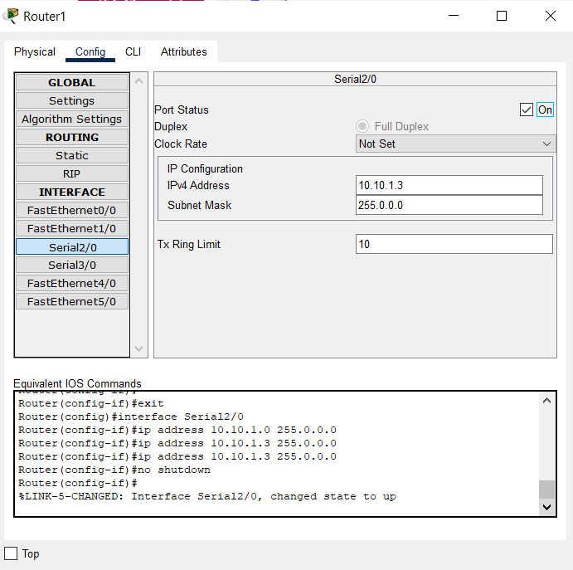

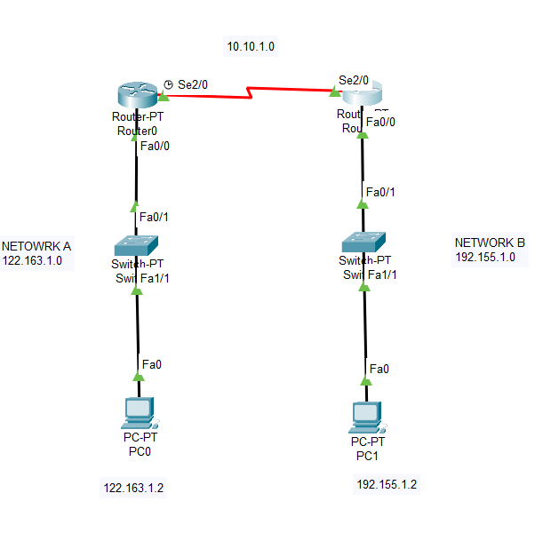

Step 5: Implementing RIP

For Router 0:

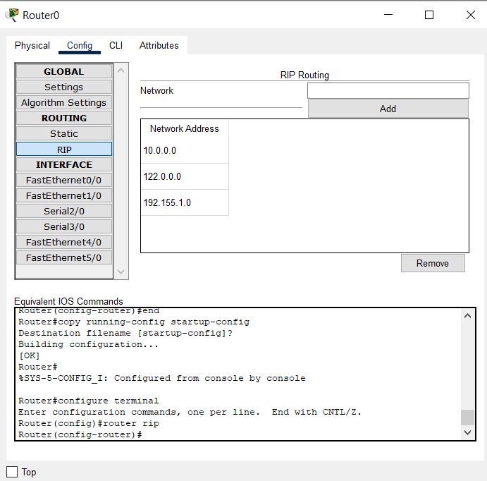

For Router 1:

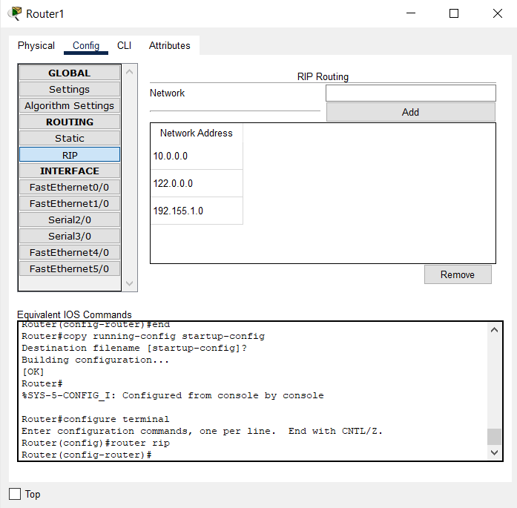

Step 6:Take a simple PDU and check if the network is working

Steps

1)

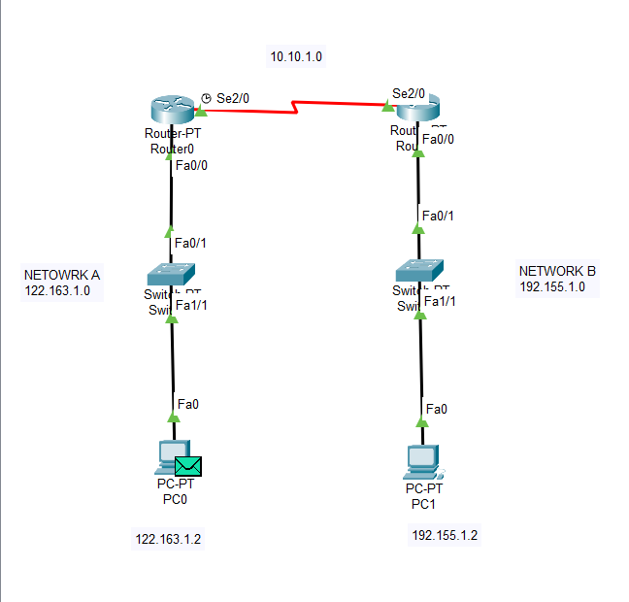

2)

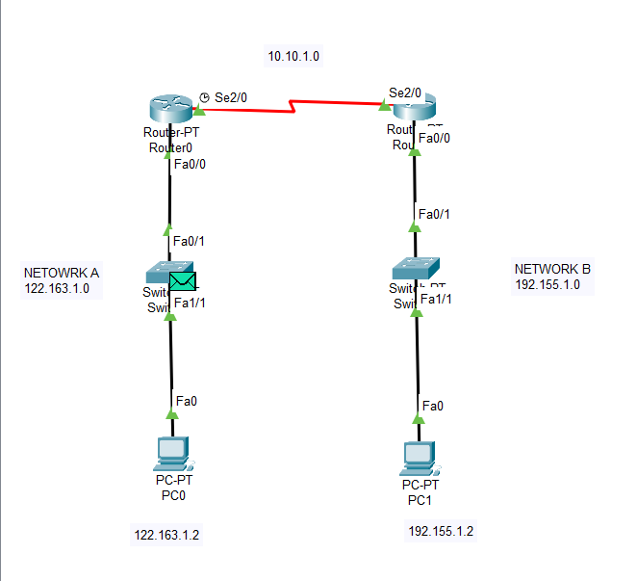

3)

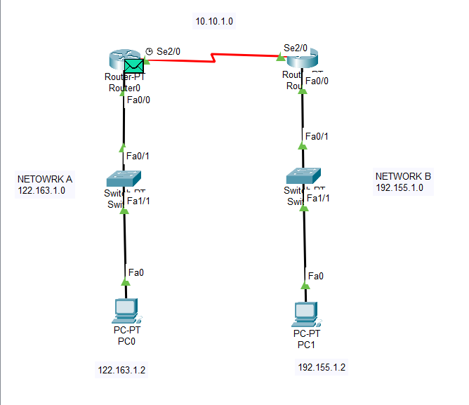

4)

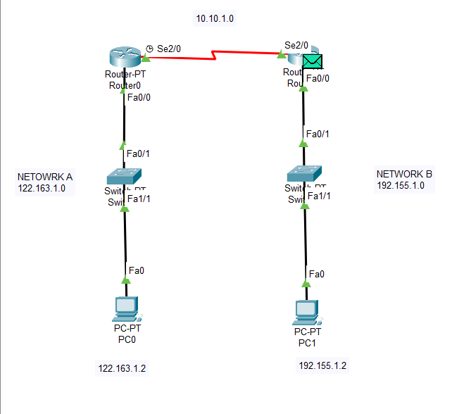

5)

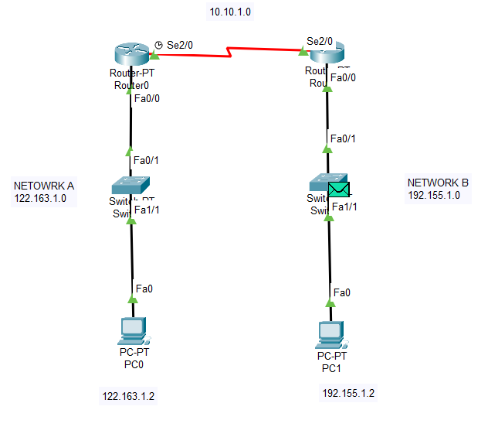

6)

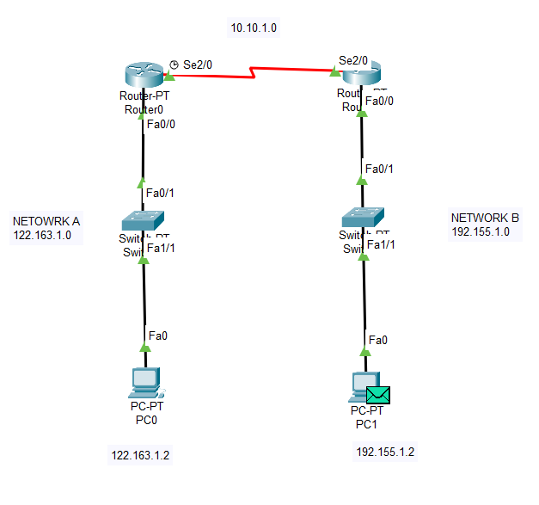

7)

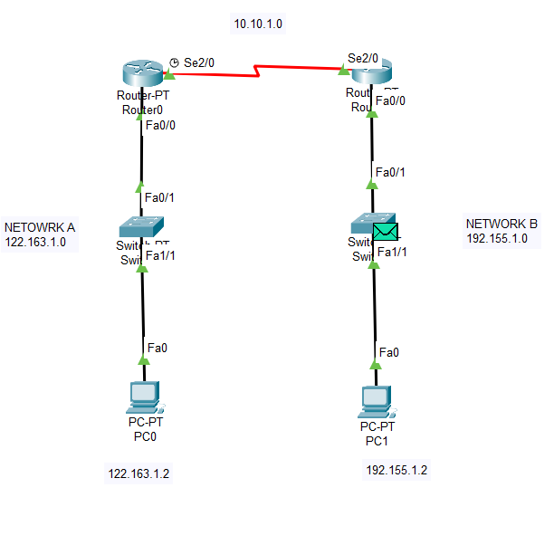

8)

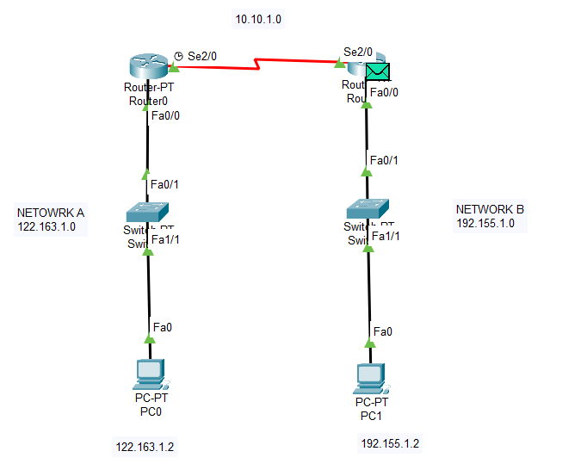

9)

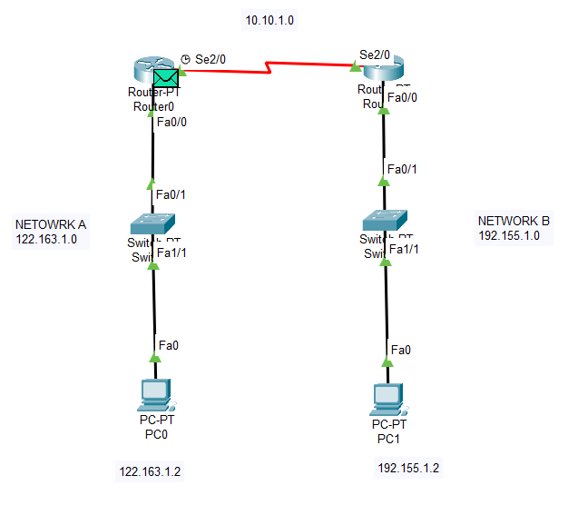

**Final Output:**

